Maseo Junior Mandiwana

ICE 3

GitHub Repository Creation:

Set Up the SQL Server Database Locally:

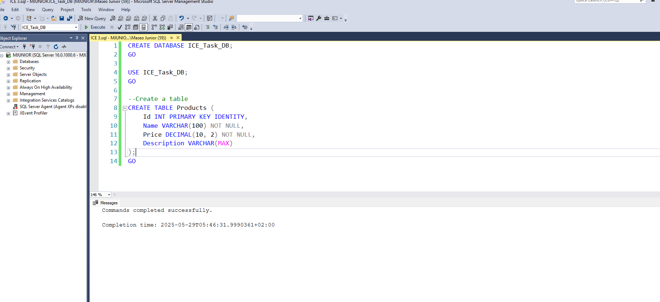

Create a Basic ASP.NET Core Web App:

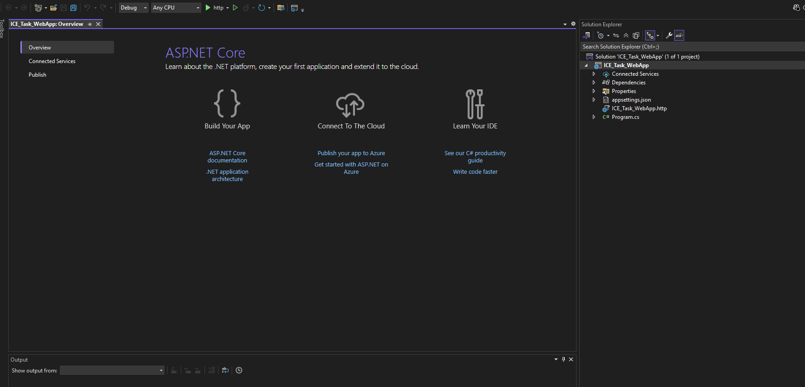

Install Required Packages:

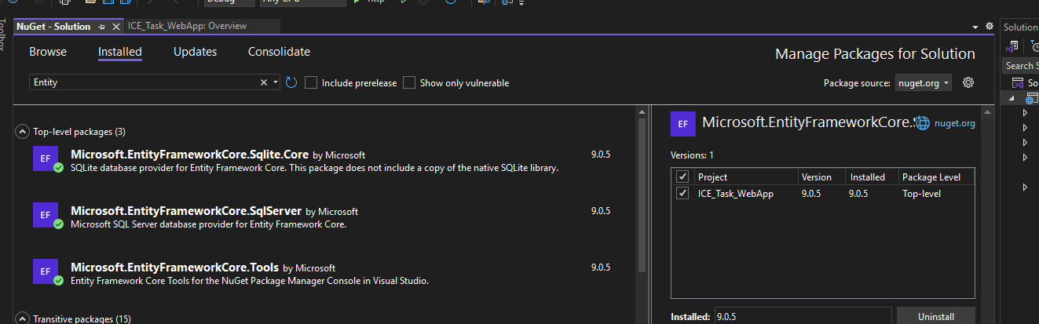

Add Connection String :

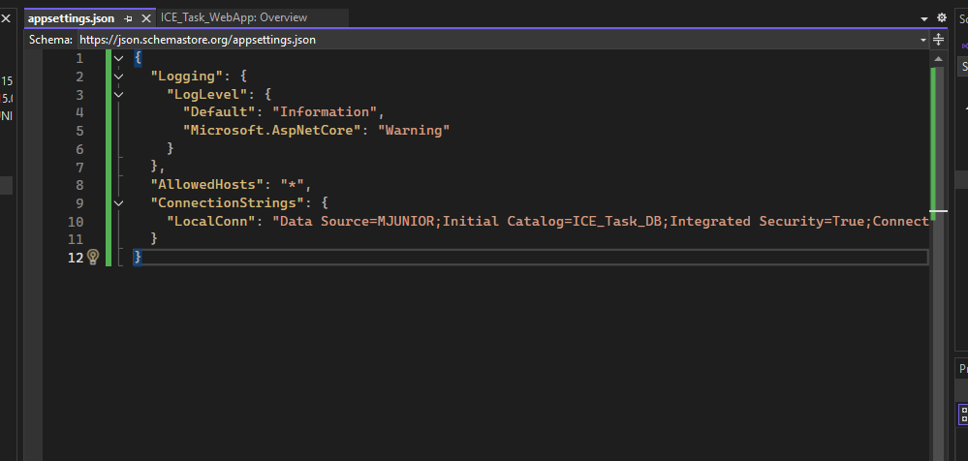

Create DbContext and Models:

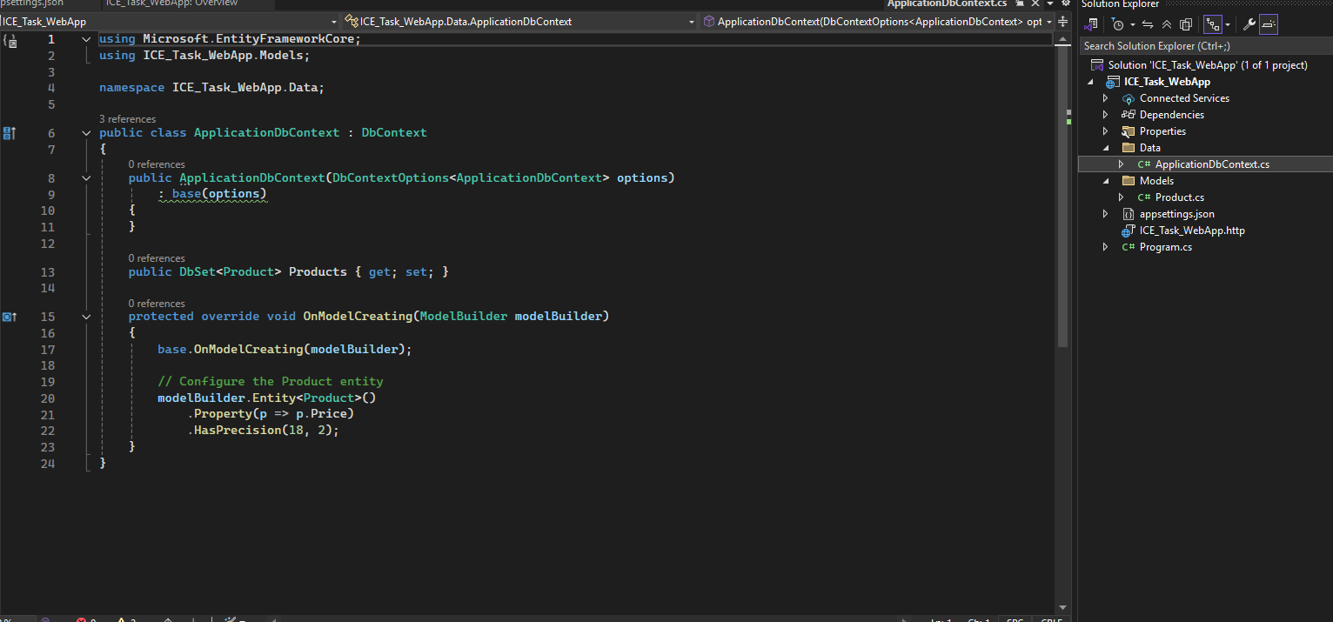

Define the Product model:

Register DbContext in Startup:



